Annexure 30, Version 1, 11 Sept 2023
Ph. D. Course Work Details

Name of the Candidate
Registration Number
Date of Registration
Title of Thesis
Name of the Supervisor
Name of Co-Supervisor (if any)

Course code* | Title of Course Work | Credits | Grade Obtained
 | Research Methodology | 4
 | Research and Publication Ethics | 2
CGPA

Grading System
% of marks | 85-100 | 75-84 | 65-74 | 55-64 | 50-54 | <50
Grade | A+ | A | B | C | D | F
Grade Value | 10 | 9 | 8 | 7 | 6 | 0

Head of the Institution Guide
(Name, Signature with Seal) (Name, Signature)

Enclosures:
- Course completion certificates
- Course work details in excel template (annexure 31) – this to be emailed to cds.mahe@manipal.edu
Note:
*Course work details to be submitted to CDS with supporting documents. Following verification, CDS will forward course work details of the candidate to the Registrar Evaluation, MAHE for the issuance of consolidated course work grade sheet.

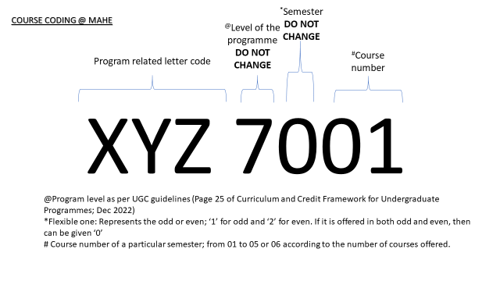

PhD Course work guidelines
As a part of course work, candidates are required to take up courses having assessment, recommended by DAC.
- Coursework proposed by the DAC shall be at Masters Level or higher.
- If the candidate takes online courses / courses/training /workshops without assessments for fulfilling Ph.D. credit requirements, the evaluation of candidates shall be conducted by the guide / department and reported in the upcoming DAC meeting.
- The minimum credit requirement for Ph.D. coursework shall be
  - 12 for candidate with master degree
  - 18 for candidate with bachelor’s degree with honors
- One credit equals to 15 contact hours for theory-based teaching or 30 hours of contact time for practical or activity-based teaching
- Ph.D. coursework includes the mandatory & specific courses
  - Mandatory courses
    - Research Methodology course with minimum 4 credits
    - Research and Publication Ethics’ with 2 credits
    - Immediately after joining, the PhD scholar should register for the mandatory course work.
    - Research methodology course should be completed in the first semester and PhD scholar must submit the certificate of course work while submitting protocol to PhD office at institution for IPAC presentation.
  - Specific courses
    - Specific courses could be additional research area specific courses proposed by DAC.
- The specific courses pertaining to thesis work may be in the form of hands on training / attending workshops suggested by the DAC. Evaluation of candidate is mandatory.

- Some of the credits can be obtained through course work done outside the home institution, preferably in a well-known research institute, pertaining to the candidates' area of research. Evaluation of candidate is mandatory.
- Candidates must complete the coursework securing minimum ‘C’ grade in each course with an overall CGPA ≥ 7.5 out of 10. For absolute grading, refer Table 1 for grade conversion.
- The DAC will review the status of course work at the preliminary and DAC 1 meeting of the candidate.
  - If there are any deficit credits/grades seen and if courses do not fulfil the MAHE PhD course work guidelines, the DAC should ask the candidate to take a repeat test or repeat the course/take alternate courses that are equivalent and ongoing, to avoid delay in coursework completion.
- If there is a delay or a shortfall, the DAC should make sure that it is resolved before the DAC 2 meeting.
- The status of course work completion/deficit and the status of action taken to be documented in the DAC minutes of meeting
- Course completion certificate issued by institution/organizer will have the details of the courses taken as part of Ph.D. work with course code, credits & grades along with the CGPA.
- Credit and grades with % marks or grading scheme followed MUST be mentioned in the course completion certificate.
- The PhD coordinator will send the details of course work taken by the candidate, in the format (30) and excel (31) specified by the university, to the CDS.
- Following verification, CDS will forward course work details of the candidate to the Registrar Evaluation, MAHE for the issuance of consolidated course work grade sheet.
- For all PhD scholars, the consolidated course work grade sheet issued by Registrar Evaluation, MAHE which will be considered for NOC issuance for thesis submission.
- The institution will retain a copy of consolidated grade sheet in the candidate’s file and the original to be given to the candidate.

Table 1: Grading scheme
% of marks | 85-100 | 75-84 | 65-74 | 55-64 | 50-54 | <50
Grade | A+ | A | B | C | D | F
Grade Value | 10 | 9 | 8 | 7 | 6 | 0

