Title of the manuscript

1st author name¹, 2nd author name², 3rd author name³
¹Department & university, Country
²Department & university, Country
³Department & university, Country
¹1st author email; ²2nd author email; ³3rd author email

Abstract— This document gives formatting instructions for authors preparing papers for submission to NSES 2024, MIT Manipal. The authors must follow the instructions given in the document for the papers to be published. You can use this document as both an instruction set and as a template into which you can type your own text.

Keywords— Include at least 5 keywords or phrases separated with “,”

- Introduction
This document is a template. An electronic copy can be downloaded from the conference website. For questions on paper guidelines, please contact the conference publications committee as indicated on the conference website. Information about final paper submission is available from the conference website.

- Literature review

- METHODOLOGY

- RESULTS AND ANALYSIS

- CONCLUSION

Page Style
All paragraphs must be indented. All paragraphs must be justified, i.e. both left-justified and right-justified.
- Text Font of Entire Document
The entire document should be in Times New Roman or Times font. Recommended font sizes are shown in Table 1.
- Title and Author Details
Title must be in 24 pt Regular font. Author name must be in 11 pt Regular font. Author affiliation must be in 10 pt Italic. Email address must be in 9 pt Courier Regular font.

TABLE I
Font Sizes for Papers
Font Size | Appearance (in Time New Roman or Times)
Font Size | Regular | Bold | Italic
8 | table caption (in Small Caps),  figure caption,  reference item |  | reference item (partial)
9 | author email address (in Courier),  cell in a table | abstract body | abstract heading (also in Bold)
10 | level-1 heading (in Small Caps),  paragraph |  | level-2 heading,  level-3 heading,  author affiliation
11 | author name
24 | title
- Section Headings
No more than 3 levels of headings should be used. All headings must be in 10pt font. Every word in a heading must be capitalized except for short minor words as listed in Section III-B.
- Level-1 Heading: A level-1 heading must be in Small Caps, centered and numbered using uppercase Roman numerals. For example, see heading “III. Page Style” of this document. The two level-1 headings which must not be numbered are “Acknowledgment” and “References”.
- Level-2 Heading: A level-2 heading must be in Italic, left-justified and numbered using an uppercase alphabetic letter followed by a period. For example, see heading “C. Section Headings” above.
- Level-3 Heading: A level-3 heading must be indented, in Italic and numbered with an Arabic numeral followed by a right parenthesis. The level-3 heading must end with a colon. The body of the level-3 section immediately follows the level-3 heading in the same paragraph. For example, this paragraph begins with a level-3 heading.
- Figures and Tables
Figures and tables must be centered in the column.

Fig. 1 A sample line graph using colors which contrast well both on screen and on a black-and-white hard copy
- Figure Captions
Figures must be numbered using Arabic numerals. Figure captions must be in 8 pt Regular font. Captions of a single line (e.g. Fig. 2) must be centered whereas multi-line captions must be justified (e.g. Fig. 1). Captions with figure numbers must be placed after their associated figures, as shown in Fig. 1.
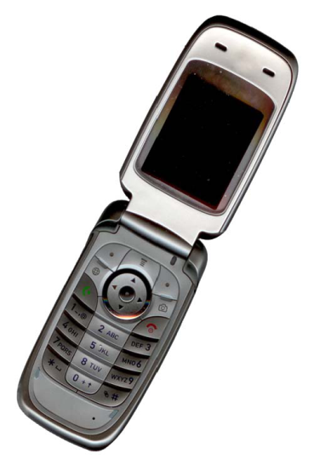
Fig. 2 Example of an image with acceptable resolution
- Table Captions
Tables must be numbered using uppercase Roman numerals. Table captions must be centred and in 8 pt Regular font with Small Caps. Captions with table numbers must be placed before their associated tables, as shown in Table 1.
- References
The heading of the References section must not be numbered. All reference items must be in 8 pt font. Please use Regular and Italic styles to distinguish different fields as shown in the References section. Number the reference items consecutively in square brackets (e.g. [1]).
When referring to a reference item, please simply use the reference number, as in [2]. Do not use “Ref. [3]” or “Reference [3]” except at the beginning of a sentence, e.g. “Reference [3] shows …”. Multiple references are each numbered with separate brackets (e.g. [2], [3], [4]–[6]).
Examples of reference items shown in the References section include:
- example of a book in [1]
- example of a book in a series in [2]

Acknowledgement
The heading of the Acknowledgment section and the References section must not be numbered.
References
- S. M. Metev and V. P. Veiko, Laser Assisted Microtechnology, 2nd ed., R. M. Osgood, Jr., Ed. Berlin, Germany: Springer-Verlag, 1998.
- J. Breckling, Ed., The Analysis of Directional Time Series: Applications to Wind Speed and Direction, ser. Lecture Notes in Statistics. Berlin, Germany: Springer, 1989, vol. 61.
- S. Zhang, C. Zhu, J. K. O. Sin, and P. K. T. Mok, “A novel ultrathin elevated channel low-temperature poly-Si TFT,” IEEE Electron Device Lett., vol. 20, pp. 569–571, Nov. 1999.
- M. Wegmuller, J. P. von der Weid, P. Oberson, and N. Gisin, “High resolution fiber distributed measurements with coherent OFDR,” in Proc. ECOC’00, 2000, paper 11.3.4, p. 109.
- R. E. Sorace, V. S. Reinhardt, and S. A. Vaughn, “High-speed digital-to-RF converter,” U.S. Patent 5 668 842, Sept. 16, 1997.
- (2002) The IEEE website. [Online]. Available: http://www.ieee.org/

